**Advance Excel Assignment 2**

1. What does the dollar ($) sign do?

**Solution:**

There are two uses with $ sign in Excel. Primarily, the dollar symbol can **represent a currency format**, but it has another general use. Specifying an **absolute cell reference** in a formula.

If you want to display numbers as **currency values**, you need to format those numbers as currency

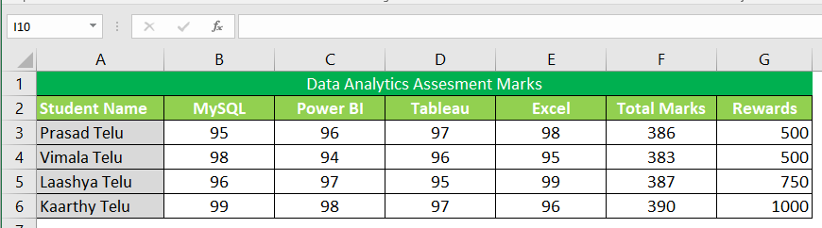

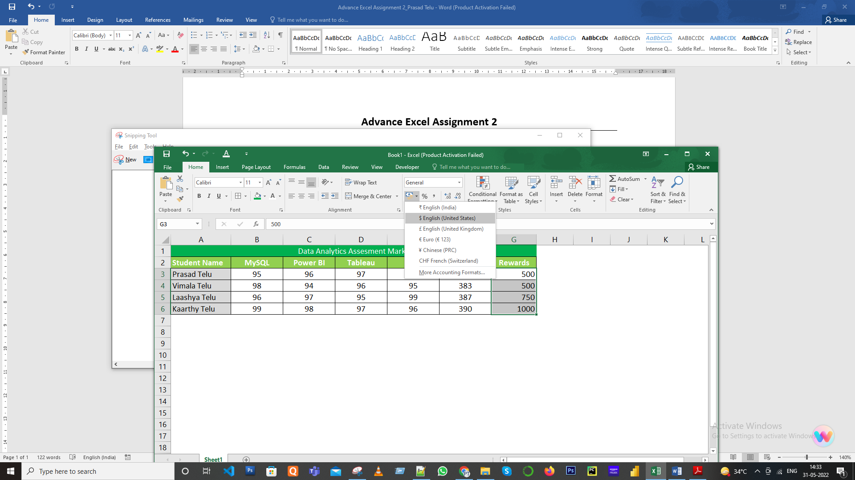

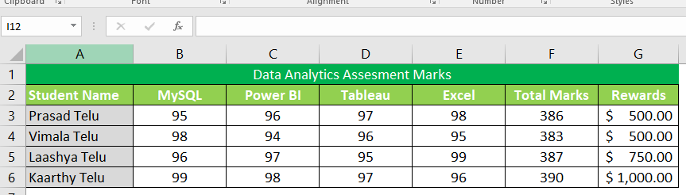

**Absolute Cell Reference**

In an absolute reference, each part of the reference (the letter that refers to the row and the number that refers to the column) is preceded by a “$” – for example, **$B$8** is an absolute reference to cell C12 to C15. Wherever the formula is copied or moved, it always refers to cell $B$8.

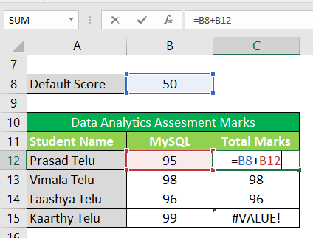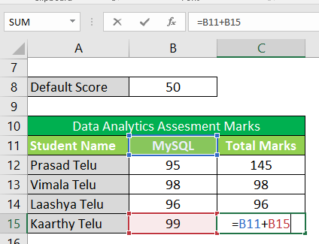

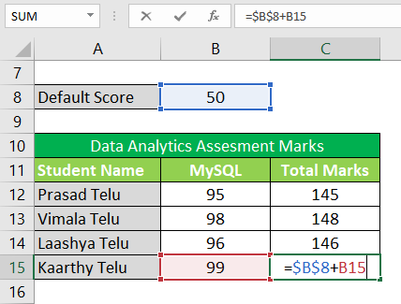 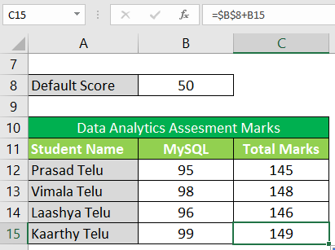

1. How to Change the Reference from Relative to Absolute (or Mixed)?

**Solution:**

To change the reference from relative to absolute, you need to add a dollar sign before the column notation and row number.

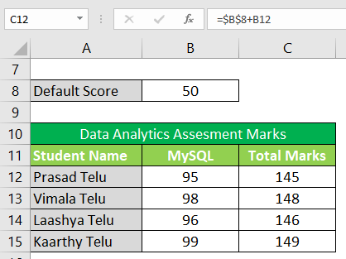

For example, B8 is a relative cell reference, and it would become absolute when you make it $B$8.

**Press F4 key once:** The cell reference changes from B8 to $B$8 (becomes ‘absolute’ from ‘relative’).

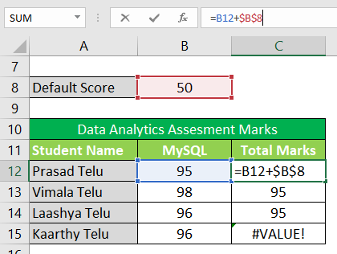

**Press F4 key two times:** The cell reference changes from B8 to B$8 (changes to mixed reference where the row is locked).

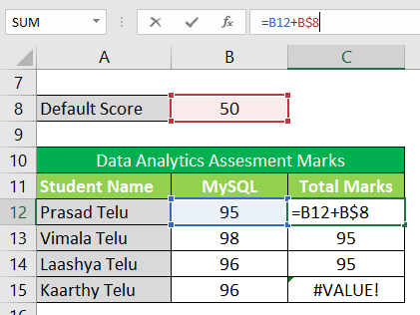

**Press F4 key three times:** The cell reference changes from B8 to $B8 (changes to mixed reference where the column is locked).

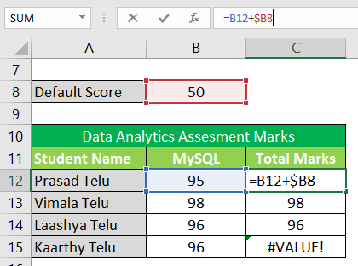

**Press F4 key four times:** The cell reference becomes B8 again.

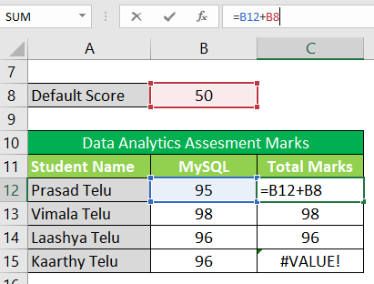

1. Explain the order of operations in excel?

# Solution:

The order in which Excel performs **operations in formulas.**

PEMDAS (Parentheses, Exponents, Multiplication, Division, Addition, Subtraction)

|  |  |
| --- | --- |
| **Operation** | **Example** |
| **P**arentheses | 10 + **(6-2)** / 2^2 |
| **E**xponents | 10 + 4 / **2^2** |
| **M**ultiplication and **D**ivision | 10 + **4/4** |
| **A**ddition and **S**ubtraction | **10 + 1** |
| Result | 11 |

1. What, according to you, are the top 5 functions in excel and write a basic syntax for any of two?

**Solution:**

There is plethora of functions available in Excel, out of top 5 functions which I regularly used in my project tasks.

1. SUM
2. VLOOKUP
3. CONCATENATE
4. TRIM
5. LEN
6. **SUM**: The sum function is the most used function when it comes to computing data on Excel. The syntax formula for sum function is “=SUM” (number1, number2, etc.).

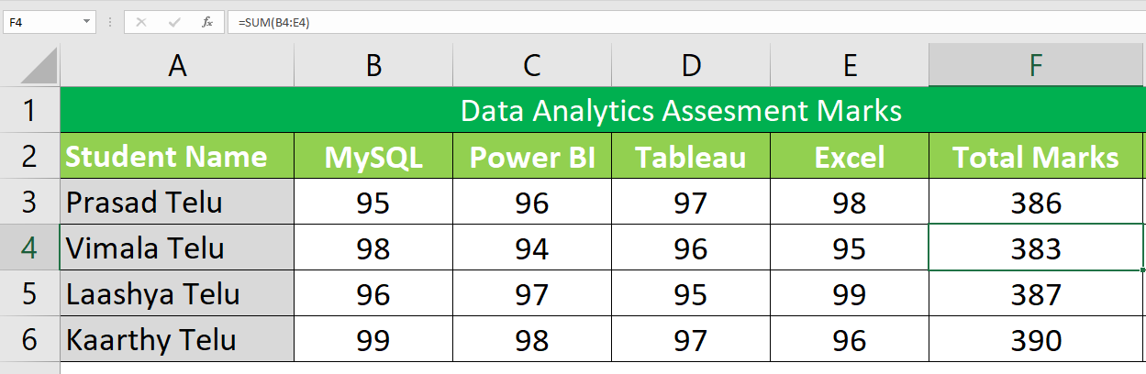

In this image, the sum function for the cells B4 through E4 is obtained through the formula

**Syntax :** “=SUM(B4:E4)”, giving you the result of 383.

1. **VLOOKUP:** VLookup is powerful Excel function that is often overlooked. It's very useful when to find specific data on a large table. You can also use VLookup to search for names, phone number, or specific data on your sheet. Instead of manually looking hundreds of data, the VLookup function makes this process faster and more efficient.

**Syntax :** The *VLookup*formula is “=VLOOKUP” (lookup_value, table_array, col_index_num, *range_lookup*).

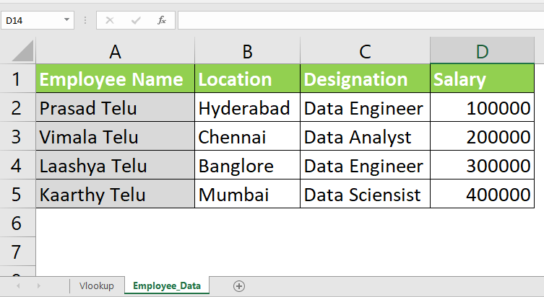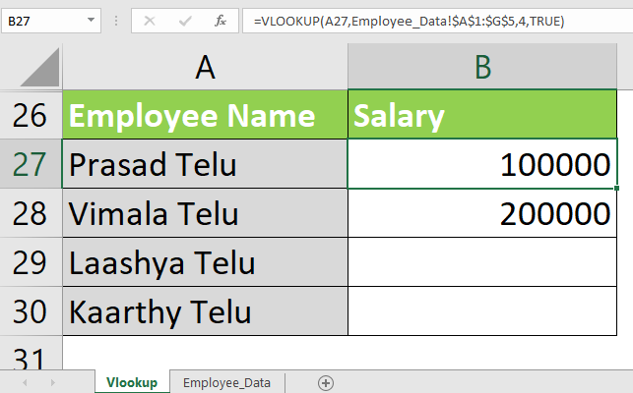

1. **Concatenate:** To combine two or more cells then into one cell, use the concatenate operator (&) or the CONCATENATE function.

**Syntax :** CONCATENATE(text1, [text2], …)

For example, to combine the values from cells A2 and B2, just enter the following formula in a different cell: **=CONCATENATE(A2, B2)**

To separate the combined values with a space, type the space character (" ") in the arguments list: **=CONCATENATE(A2, " ", B2)**

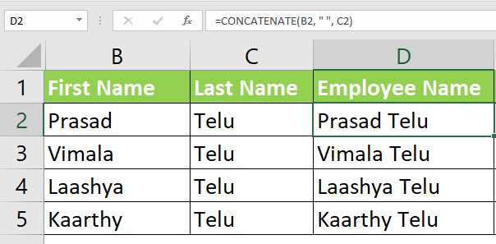

1. **Trim:**

There are several ways to remove unwanted spaces in Excel, with the TRIM function being the easiest one:

**Syntax :** Trim()

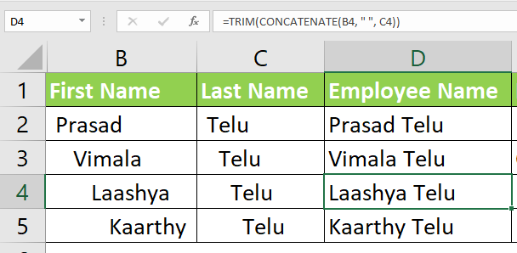

1. **LEN**

Whenever you want to know the number of characters in a certain cell, LEN is the function to use

Excel LEN function counts absolutely all characters including spaces:

**Syntax : LEN()..**

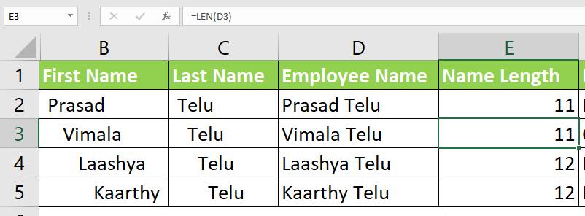

1. When would you use the subtotal function?

**Solution:**

The SUBTOTAL function is used to display total rows in an Excel spreadsheet. Excel can automatically insert a SUBTOTAL function and use the drop-down menu to change its behaviour to display maximum, minimum, average, and so on.

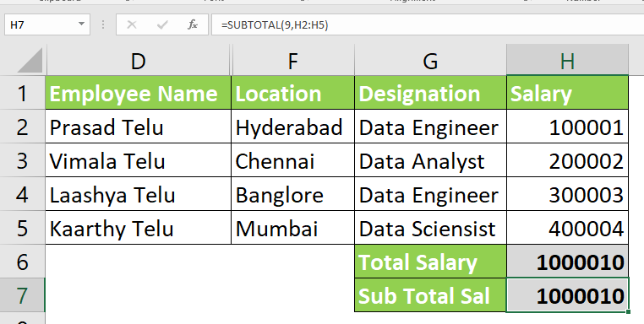

**Note**: Filter the Location dropdown and uncheck Hyderabad and Mumbai and Subtotal function automatically calculate the values displayed in the sheet, however Total Salary sum values appears irrespective of the values displayed in the sheet.

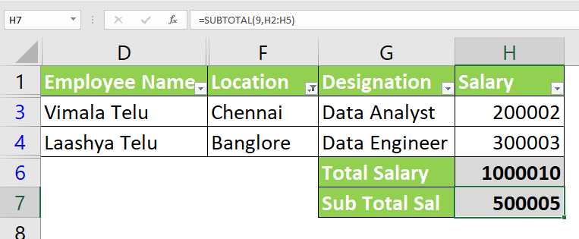

1. What is the syntax of the vlookup function? Explain the terms in it?

**Solution:**

The VLOOKUP function is a pre-created function in Excel that allows you to search between columns. VLOOKUP is a function to lookup up and retrieve data in a table. The "V" in VLOOKUP stands for vertical, which means the data in the table must be arranged vertically, with data in rows.

**Syntax:**

=VLOOKUP(lookup_value, table_array, col_index_num, [range_lookup])

**Lookup_value:** Select the cell where search values will be entered.

**Table_array:** The table range, including all cells in the table.

**Col_index_num:** The data which is being looked up. The input is the number of the column, counted from the left.

**Range_lookup:** TRUE if numbers (1) or FALSE if text (0).



